**Assignment: Analysis Operations**

**Q 1: Find the customer with the highest overall profit. What is his/her profit ratio?**

**Step 1: Open the superstoreus2015 excel data set.   
Step 2: Drag Orders sheet to sheet area.**

**Step 3: Go to sheet 1 and add Customer name as rows and profit as column**

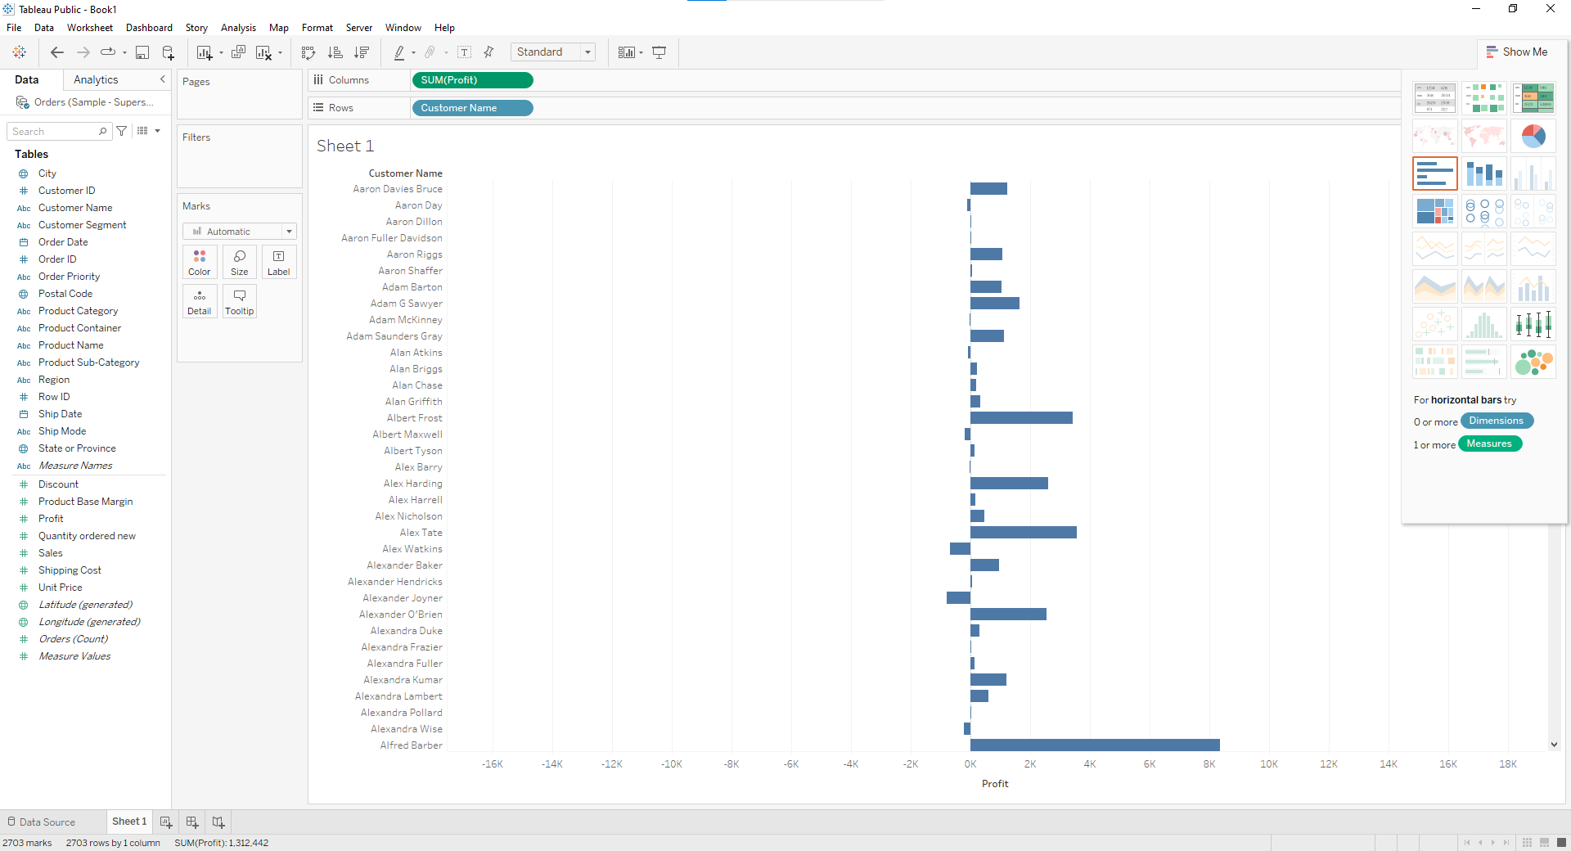

**Step 4: Sort the data by clicking on Profit label on bottom** 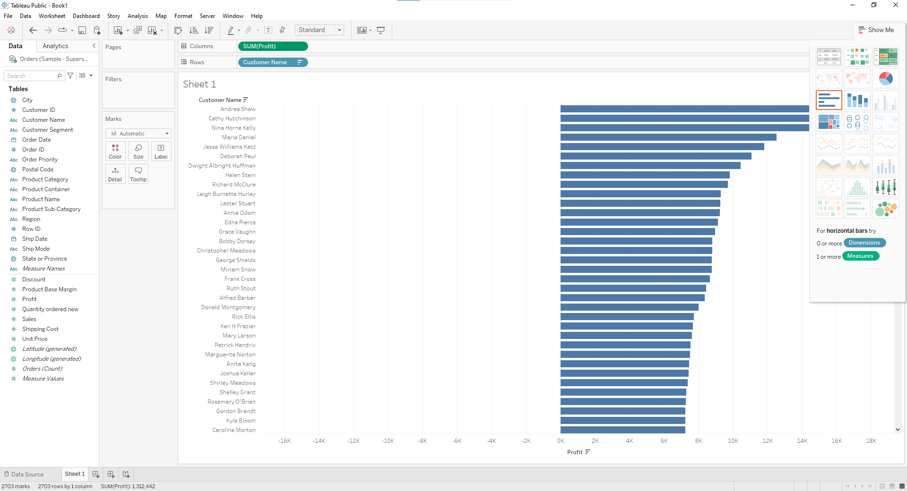

**Step 5: To calculate profit Ratio**

**Profit Ratio= (Sum([Profit])/Sum([Sales]))**

**This formula needs to be entered as tooltip or label Click on Analysis>Create Calculated Field and enter the formula**

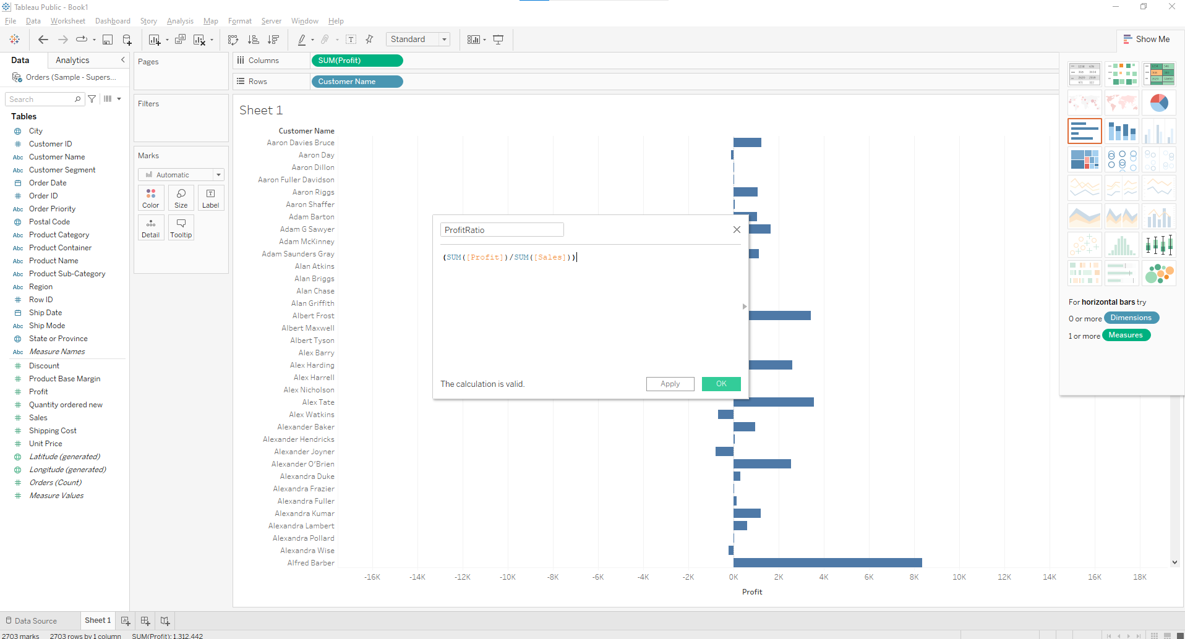

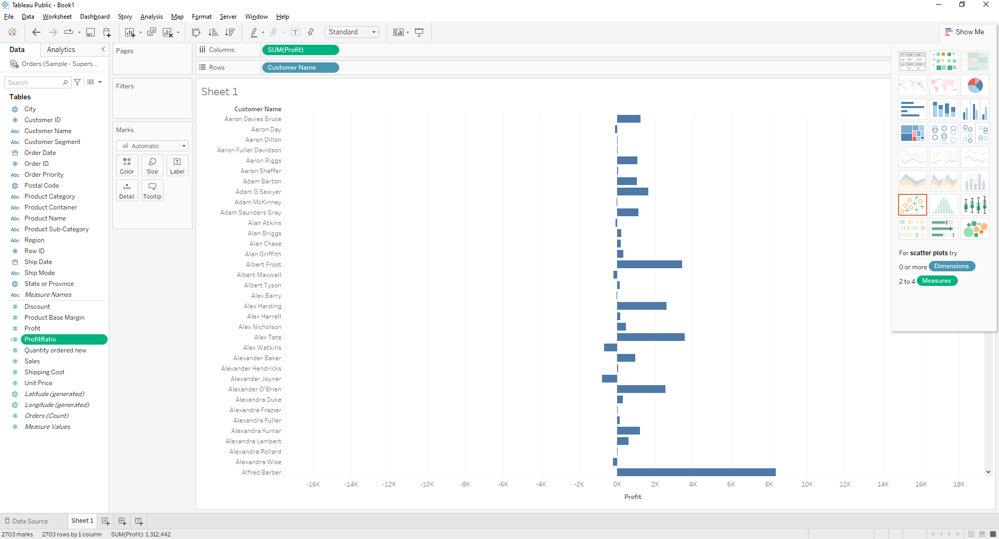

You can see Calculation1 in measures. Drag is to Marks area.

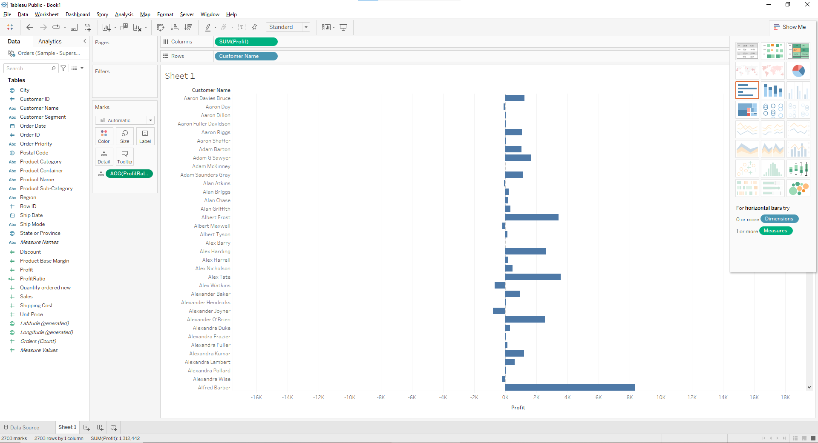

**Final answer is:**

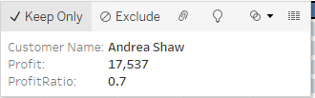

**Q2: Which state has the highest Sales (Sum)? What is the total Sales for that state?**

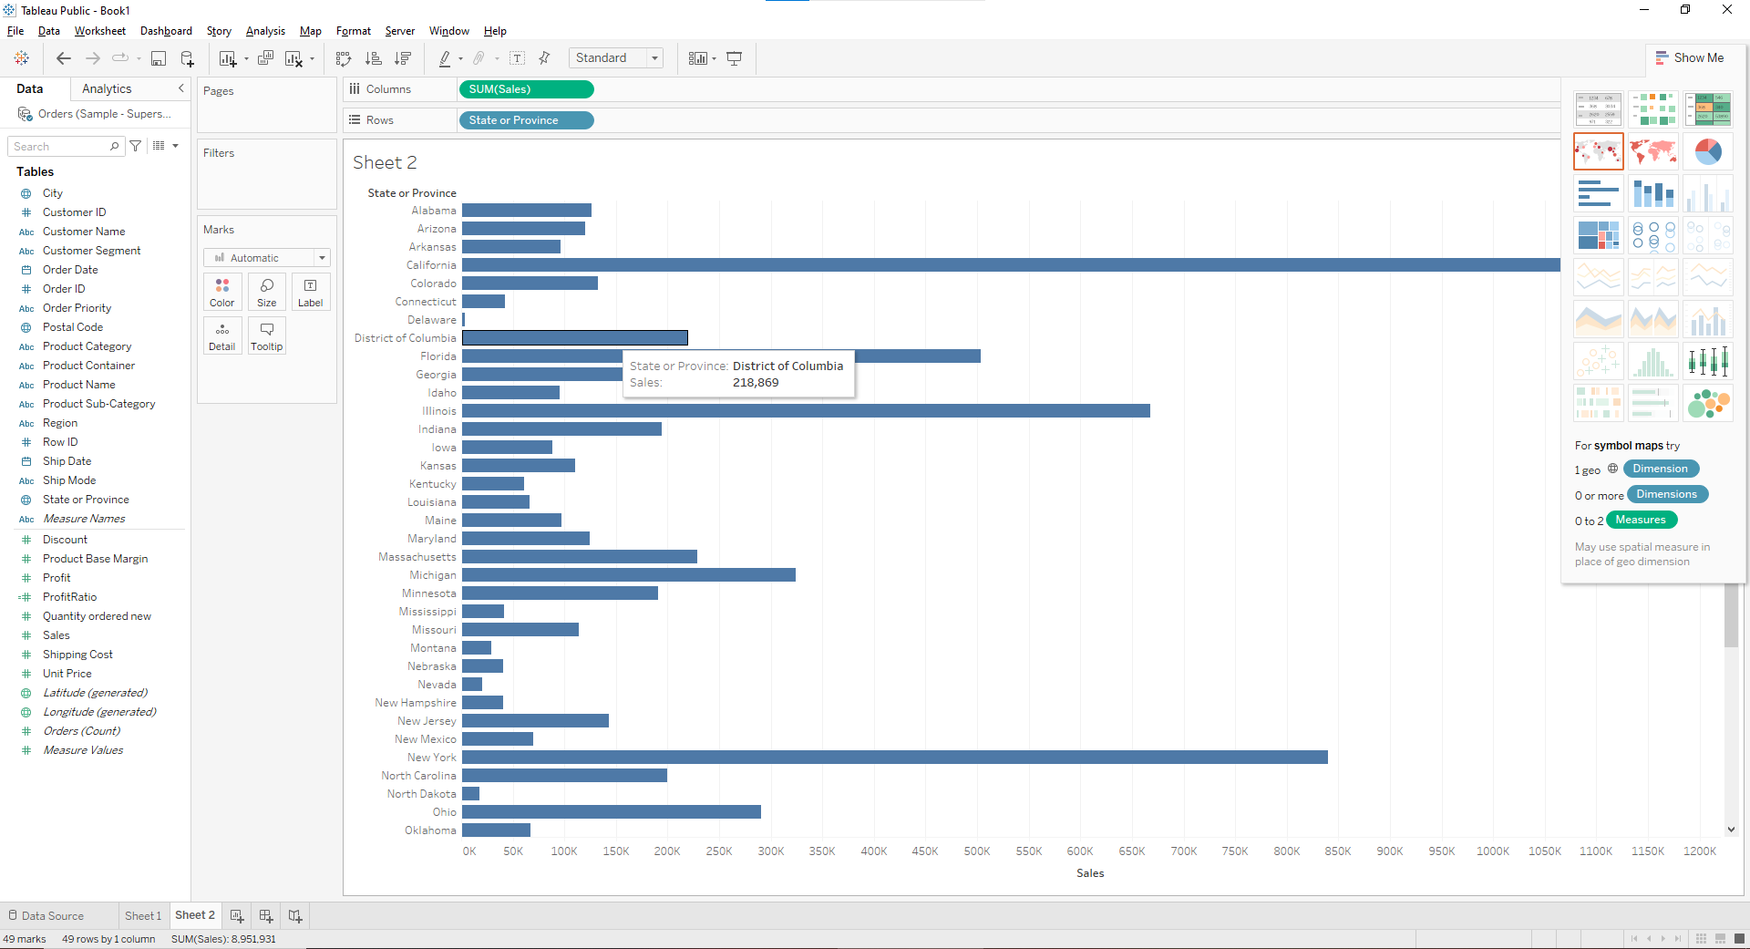

**Q3. Which customer segment has both the highest order quantity and average discount rate? What is the order quantity and average discount rate for that state?**

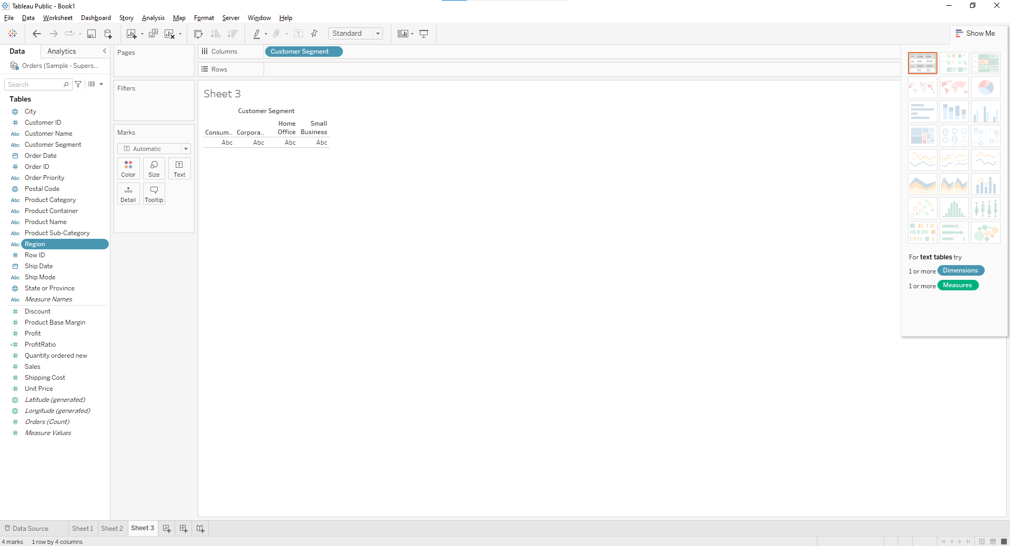

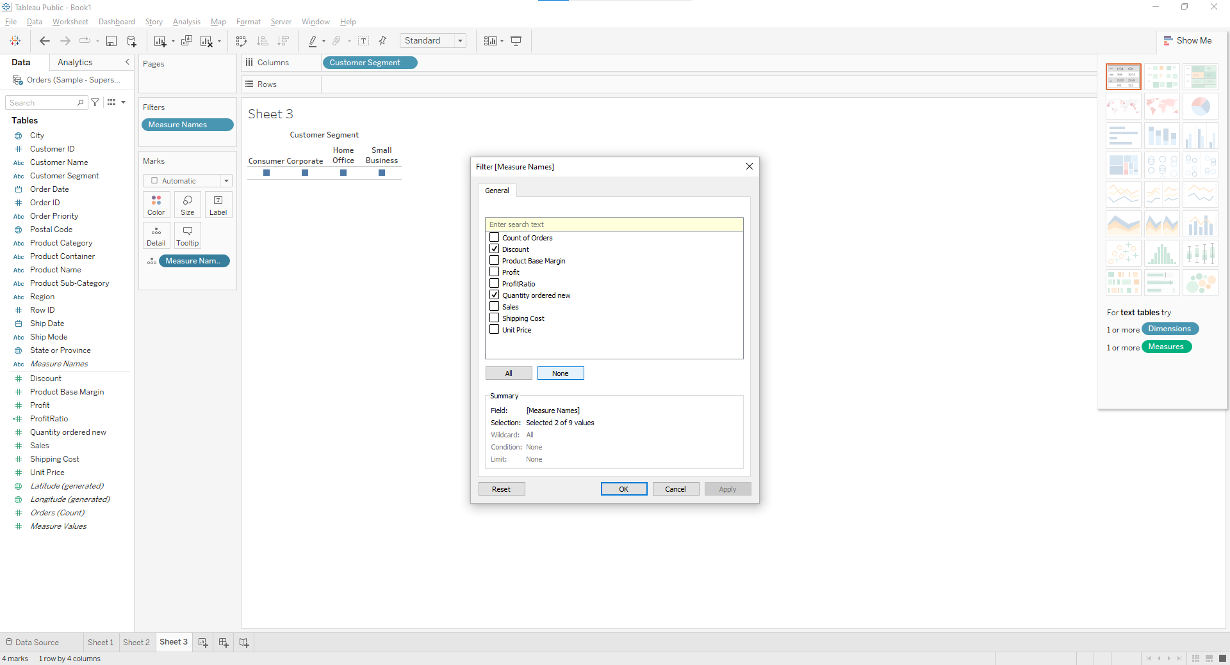

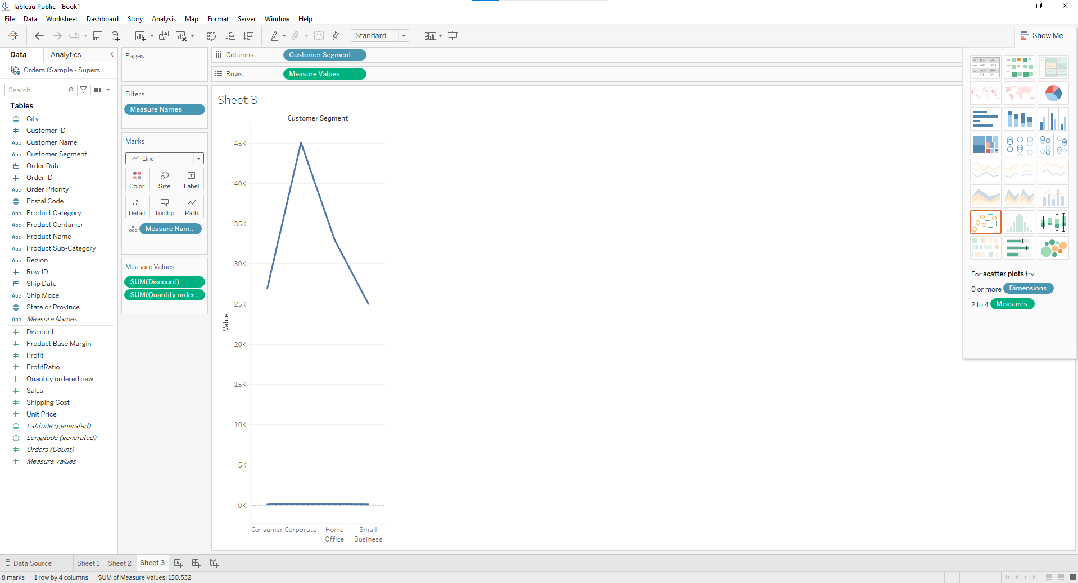

**Q4. Which Product Category has the highest total Sales? Which Product Category has the worst Profit? Name the Product Category and $ amount for each**

1. **Bar Chart displaying total Sales for each Product Category**

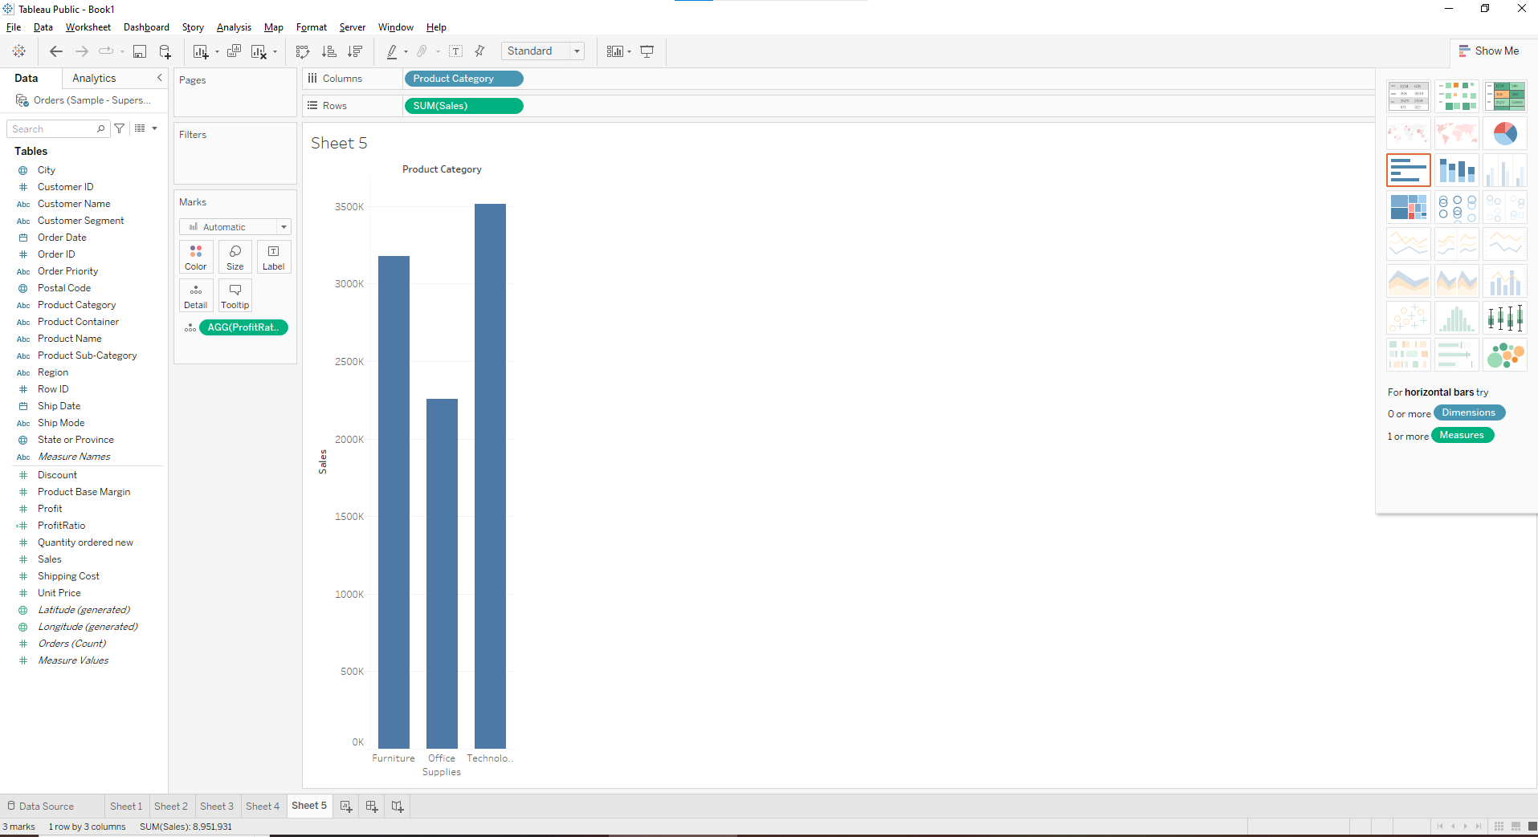

1. **Add a color scale indicating Profit**

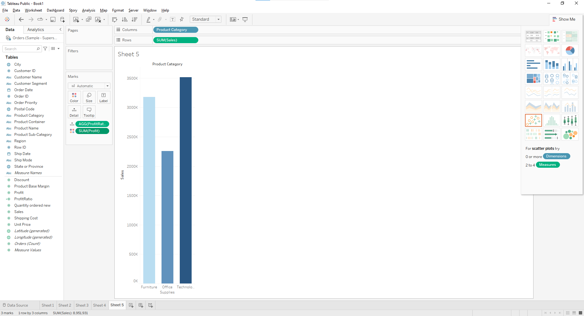

**C. Each Product Category labeled with total Sales and Each Product Category labeled with Profit**

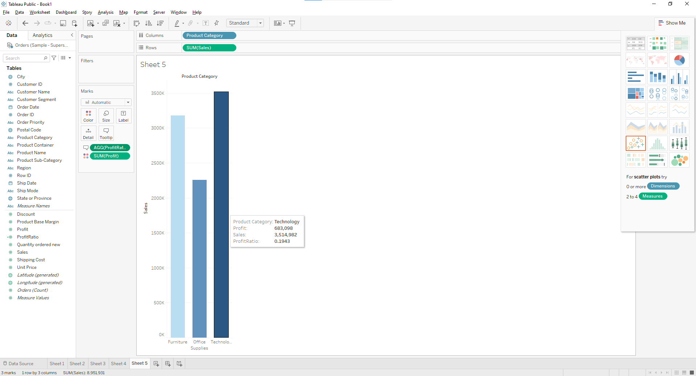

**Q5. Use the same visualization created for Question #4.What was the Profit on Technology (Product Category) in Boca Raton (City)**

1. **Add Filter City**

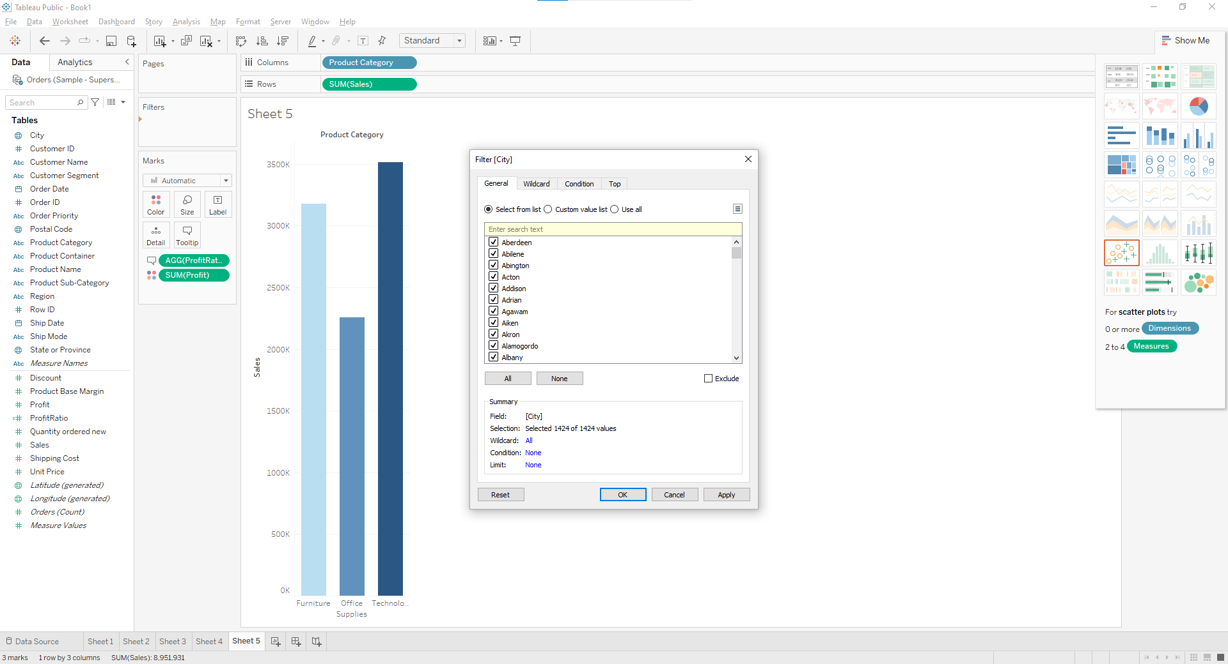

1. **Select the city to show a single bar for the city**

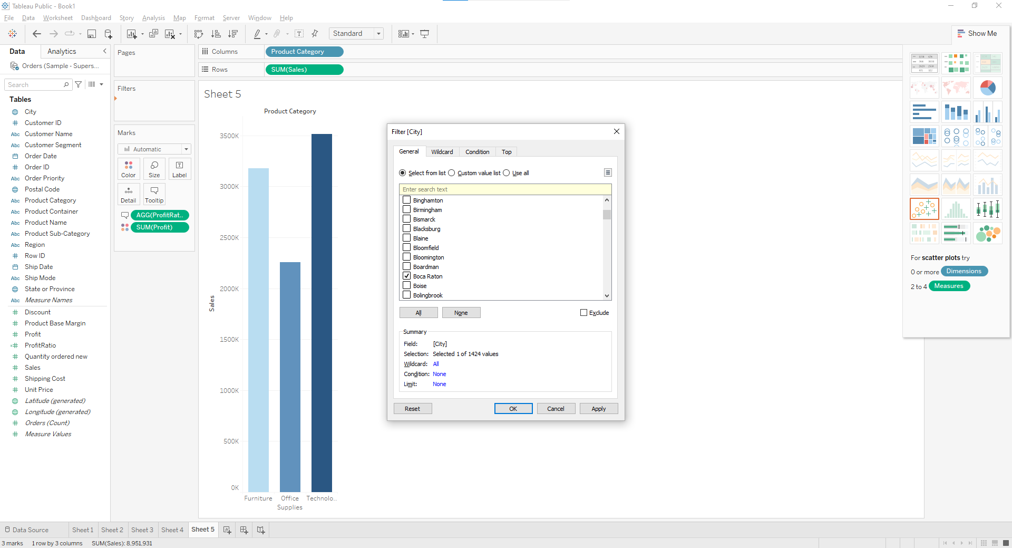

1. **Apply a filter for Technology**

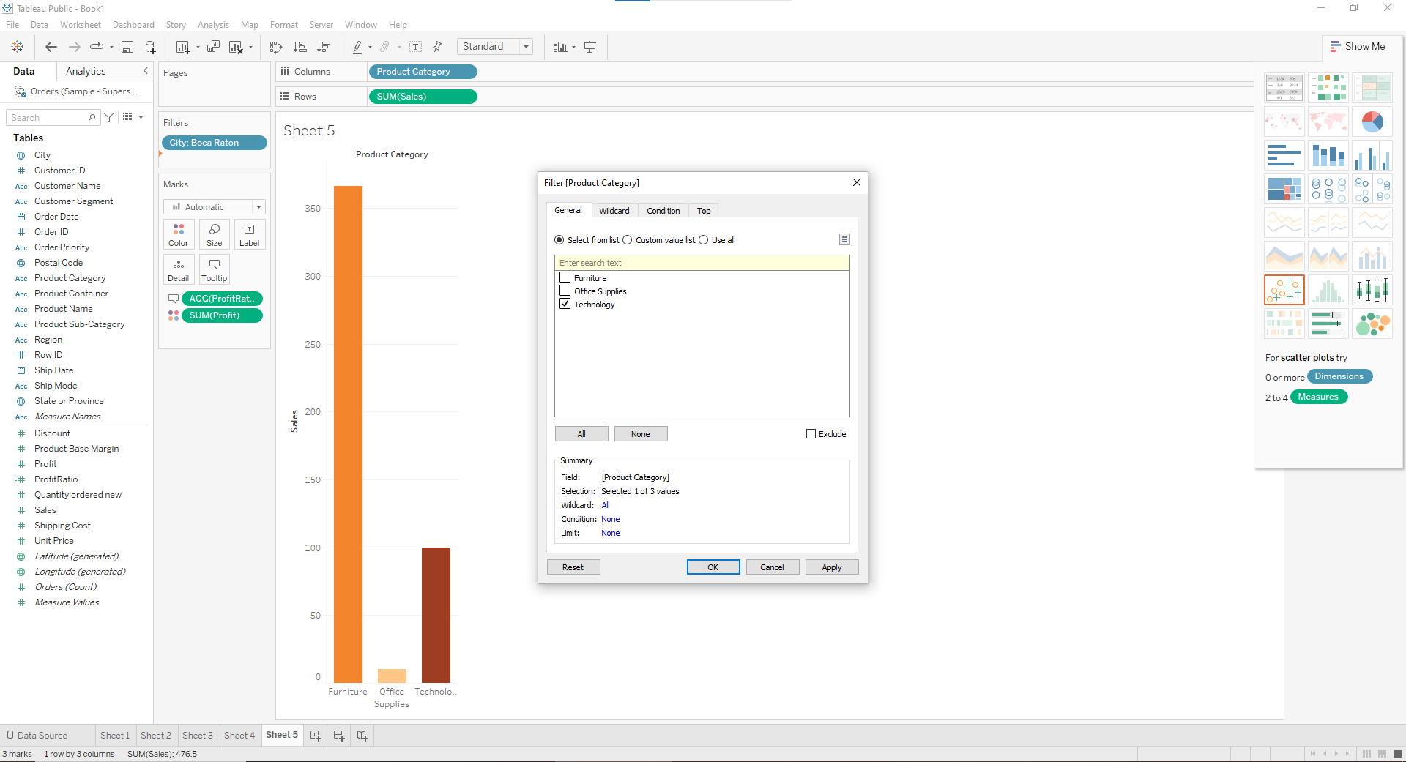

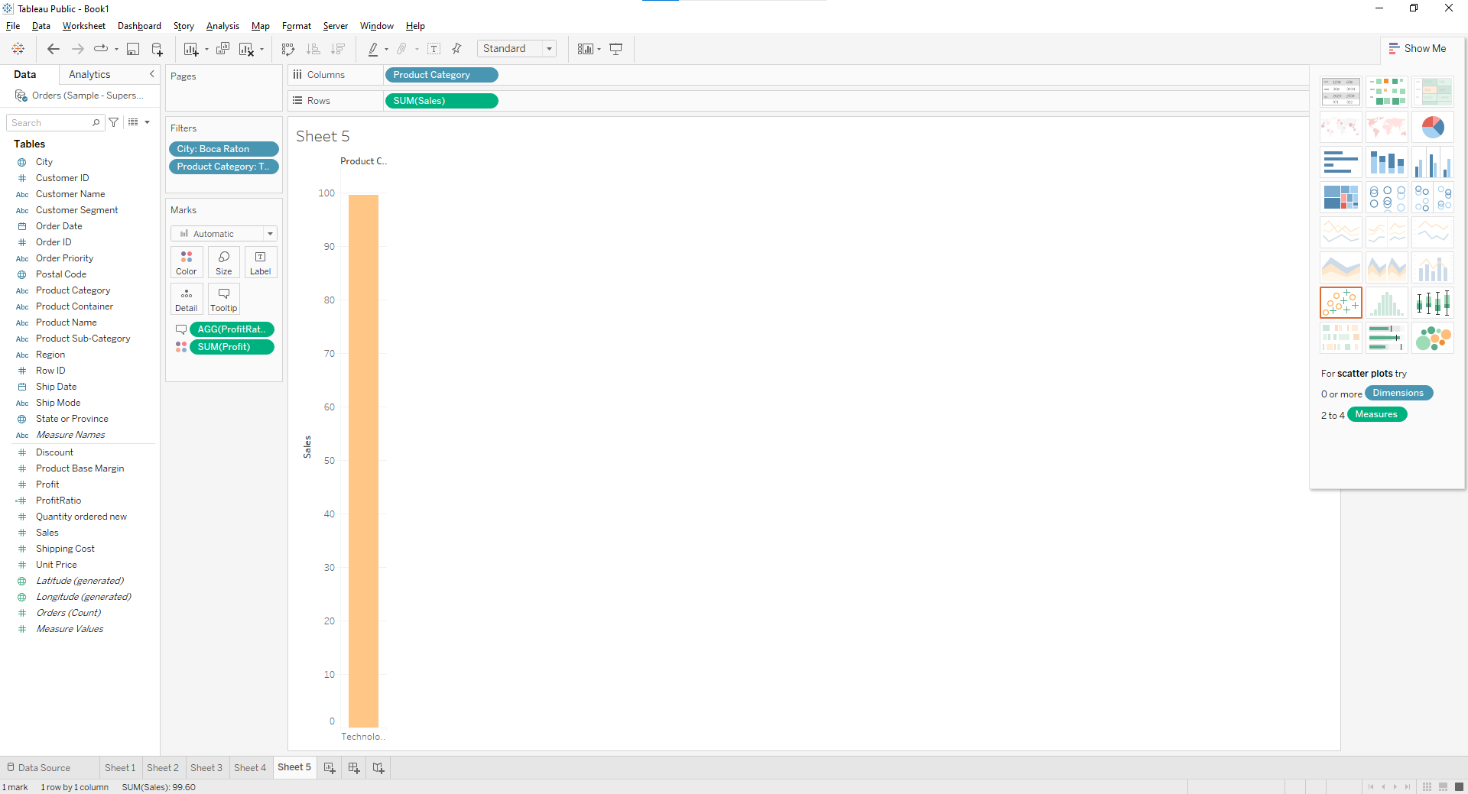

**Q6. Which Product Department has the highest Shipping Costs? Name the Department and cost.**

1. **Packed bubble chart showing each Product Department as a colored bubble.**

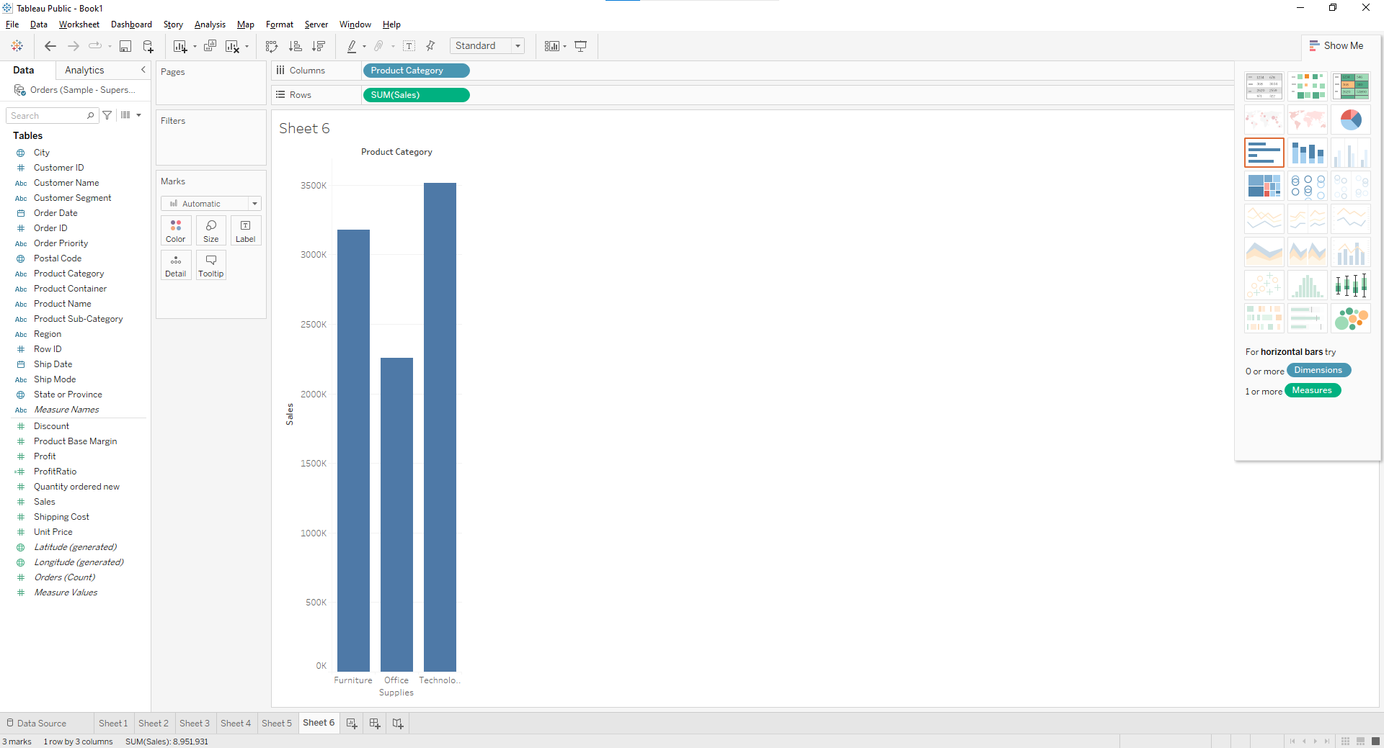

1. **Use Shipping Cost to display the size of each bubble**

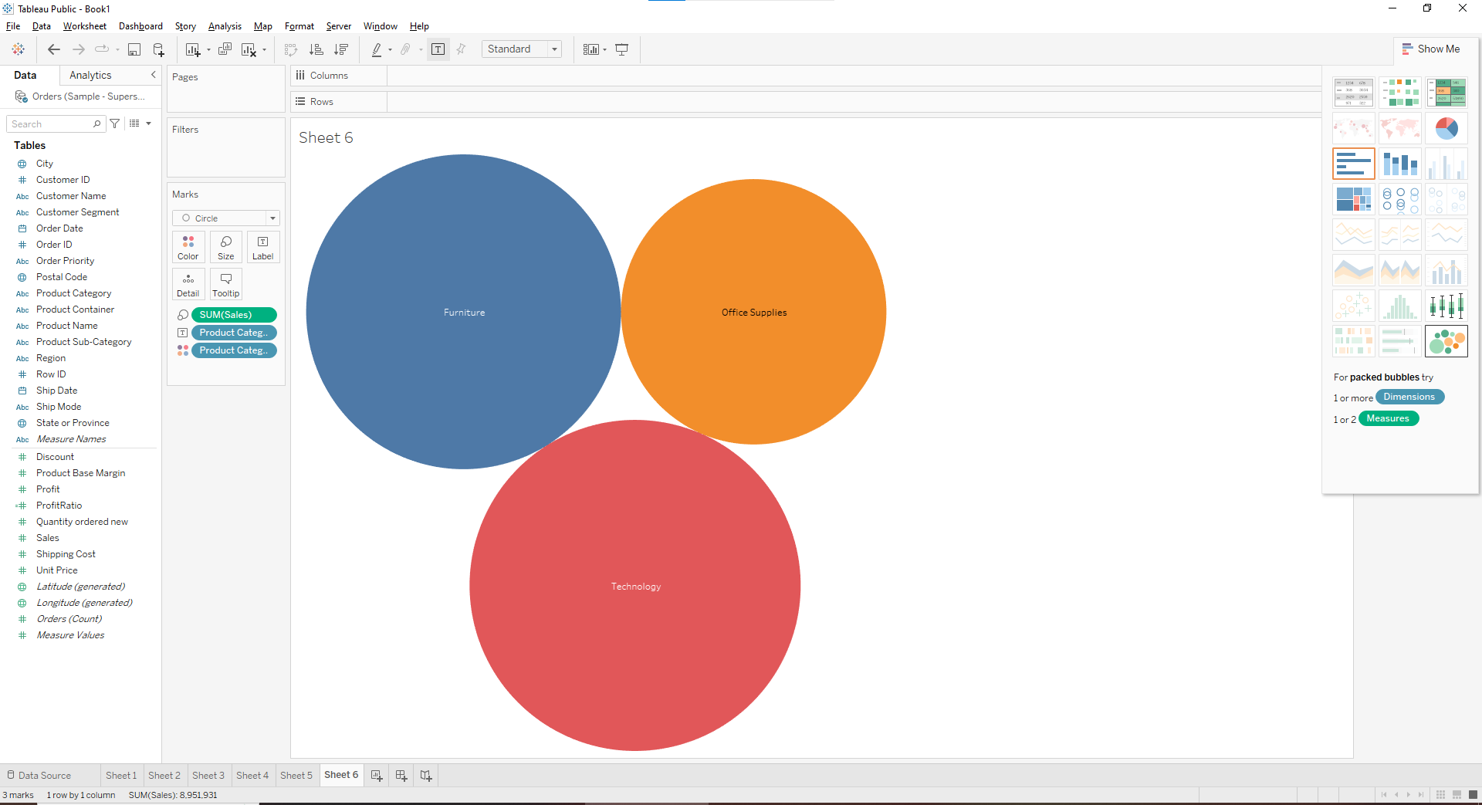

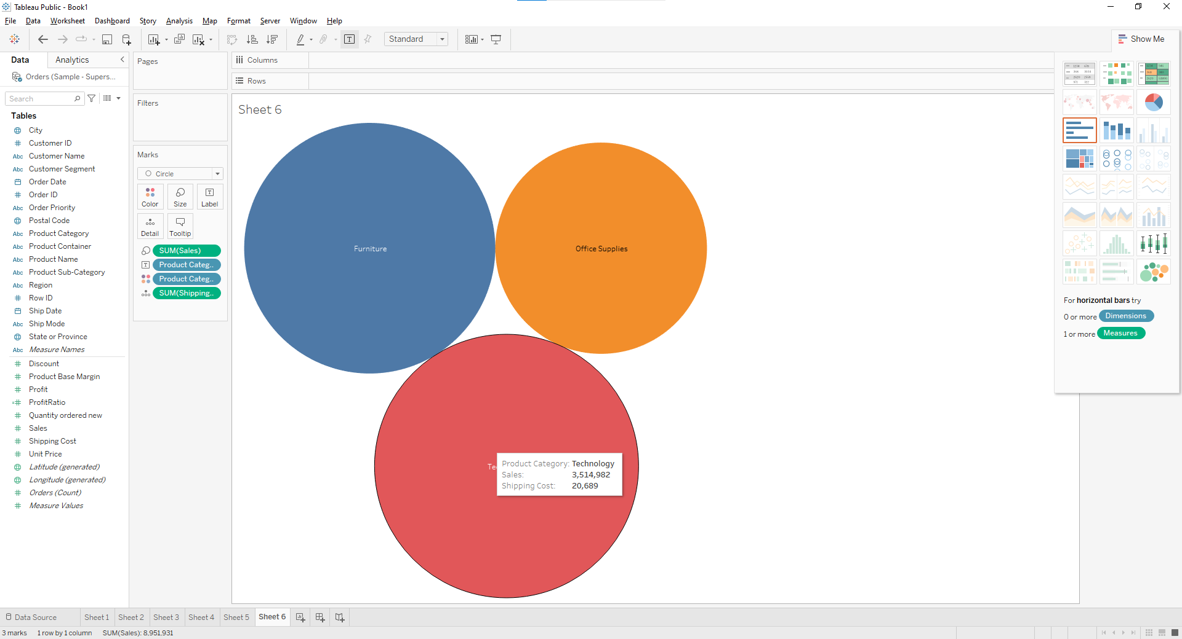

**Q7. Use the same visualization created for Question #6. What was the shipping cost of Office Supplies for Xerox 1905 in the Home Customer Segment in Cambridge?**

1. **Apply filters as per requirement**

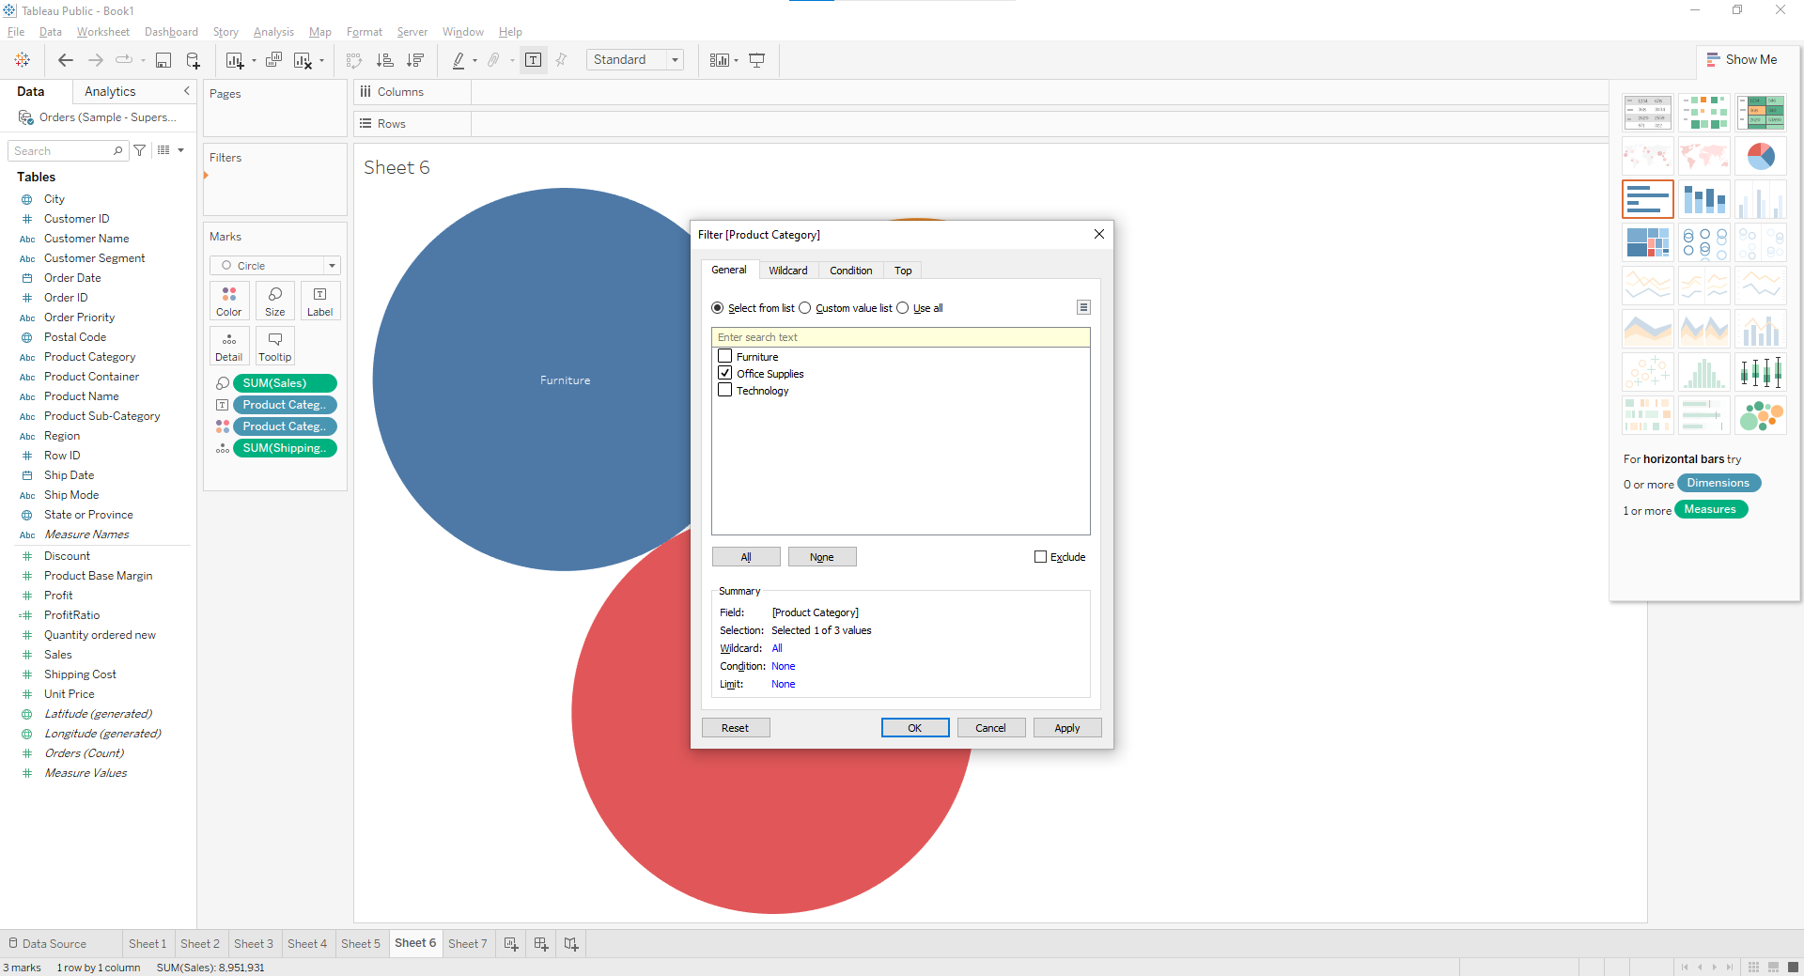

1. **Apply city Filter**

